DRE TRANSACTION ORCHESTRATOR
Two-Tier Compliance Pipeline and Final Audit Receipt
How deterministic rules, AI consensus, financial outcomes, fallback handling, and demo execution are coordinated end to end

COMPONENT PURPOSE
TransactionOrchestrator is the coordination layer for the demo. It calls the deterministic compliance engine first, exits early when semantic review is unnecessary, invokes the Azure AI consensus wrapper only for flagged narratives, and returns one FinalAuditedTransaction receipt for downstream use.
Deterministic first • AI only when needed • auditable typed output • fail-safe escalation

How the Orchestration Pipeline Works
The orchestrator composes the two previously defined components into one transaction-processing path. Every billing item passes through deterministic evaluation. Only items marked needs_ai_consensus continue to the multi-agent wrapper. The final receipt normalizes both pathways into a common audit contract.
Stage | Behavior | Output
1. Construct services | Instantiate DeterministicComplianceEngine and AzureAiConsensusWrapper. | Ready orchestration dependencies.
2. Tier 1 evaluation | Call evaluatePayload with the raw billing payload. | Adjusted values, violations, sanitized narrative, and AI-needed flag.
3. Early-exit decision | If needs_ai_consensus is false, return immediately. | DETERMINISTIC_ONLY receipt with no AI votes.
4. Tier 2 consensus | Pass transaction ID, sanitized narrative, and hourly rate to executeConsensusLoop. | ConsensusResult with final action, status, votes, and narrative.
5. Financial finalization | Use adjusted value by default; set final value to zero for HARD_REJECT. | Final value and total difference from original value.
6. Audit packaging | Map rule count and agent votes into technical_log. | Typed FinalAuditedTransaction.
7. Emergency fallback | On consensus error, preserve deterministic output and escalate to human review. | Safe deterministic receipt without AI votes.

The Unified Audit Receipt
Field Group | Purpose
Transaction identity | Connects the result to the original line item.
Financial values | Carries original, final, and calculated difference values.
Pipeline pathway | Records whether the item used deterministic processing only or both tiers.
Audit status | Communicates approval, modification, rejection, or human escalation.
Final narrative | Carries the sanitized or consensus-reconstructed narrative.
Technical log | Preserves deterministic violation count and compact agent vote records.

DRE Transaction Orchestration Pipeline
Deterministic rules first, AI consensus only when required, one typed audit receipt
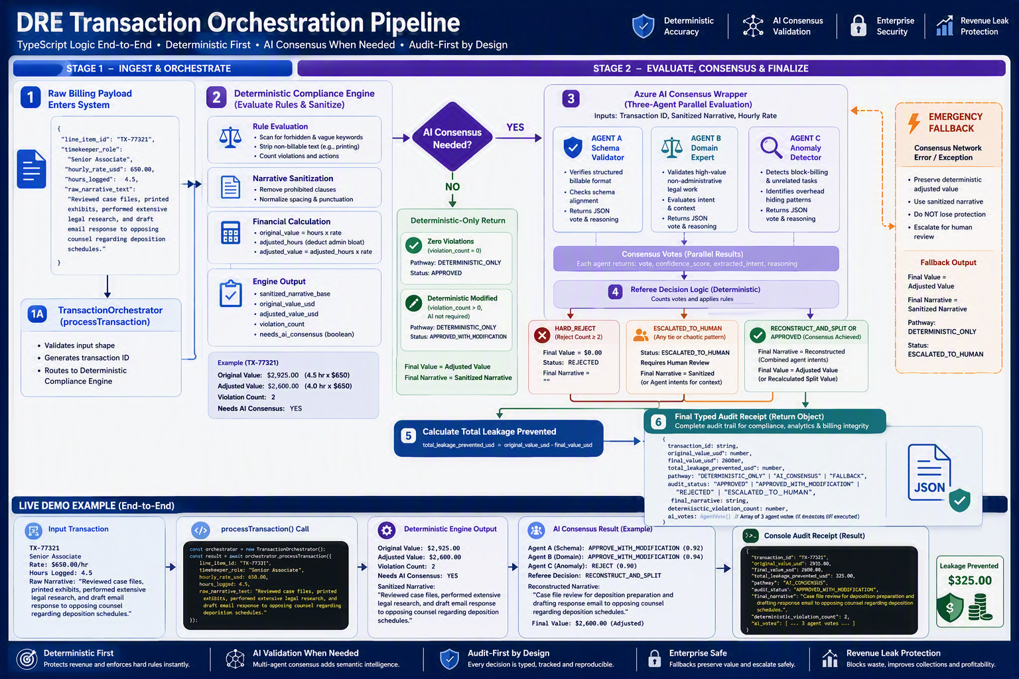

Pathway and Status Logic
Condition | Pipeline Pathway | Audit Status | Value and Narrative
No AI consensus needed; zero violations | DETERMINISTIC_ONLY | APPROVED | Adjusted deterministic value and sanitized narrative.
No AI consensus needed; one or more violations | DETERMINISTIC_ONLY | MODIFIED_BY_CONSENSUS in current code | Adjusted deterministic value and sanitized narrative.
AI action HARD_REJECT | DETERMINISTIC_AND_AI_CONSENSUS | REJECTED | Final value becomes zero; consensus narrative returned.
AI status ESCALATED_TO_HUMAN and action is not HARD_REJECT | DETERMINISTIC_AND_AI_CONSENSUS | ESCALATED_TO_HUMAN | Adjusted deterministic value; consensus narrative returned.
Other successful consensus result | DETERMINISTIC_AND_AI_CONSENSUS | MODIFIED_BY_CONSENSUS | Adjusted deterministic value; reconstructed narrative returned.
Consensus call throws | DETERMINISTIC_ONLY | ESCALATED_TO_HUMAN | Adjusted deterministic value and sanitized deterministic narrative retained.

WHY THE FALLBACK MATTERS
The catch branch does not discard the deterministic work or silently approve the transaction. It preserves the adjusted value and sanitized narrative, records no AI votes, and marks the receipt for human review. This keeps a network failure from becoming an unreviewed billing decision.

Important Code Review Findings
The following points are visible directly in the supplied logic and should be addressed before the status vocabulary is treated as final demo behavior.
Finding | Current Effect | Suggested Correction
Deterministic-only modification label | When no AI is called but violations exist, the code returns MODIFIED_BY_CONSENSUS. | Add a status such as MODIFIED_DETERMINISTICALLY or rename the current enum value.
Human escalation precedence | The code checks final_action === HARD_REJECT before consensus_status === ESCALATED_TO_HUMAN. If the wrapper returns both escalation and HARD_REJECT, the orchestrator marks REJECTED. | Check ESCALATED_TO_HUMAN first if human review must take precedence.
Reconstruct-and-split financial treatment | Successful RECONSTRUCT_AND_SPLIT keeps rulesResult.adjusted_value_usd; no additional split-value calculation occurs here. | Define whether reconstructed split entries change hours or value and calculate them explicitly if required.
Leakage terminology | total_leakage_prevented_usd equals original value minus final value, including a full hard rejection. | Consider “flagged adjustment value” until an authorized disposition confirms realized savings.
Fallback pathway label | A failed AI attempt is recorded as DETERMINISTIC_ONLY, so the attempted consensus call is not visible in pipeline_pathway. | Add an attempted-consensus or fallback indicator to the technical log.
Technical log depth | The receipt stores rule count and compact votes, but not rule IDs, reasoning, confidence, error details, or correlation IDs. | Expand the audit schema while avoiding sensitive-data leakage in logs.

DEMO READINESS PRIORITY
The first two findings affect what viewers will see in the final audit receipt. Final version will align deterministic modification label and the escalation precedence to ensure actual pathway.

Why This Component Is Important
- It turns separate rule and consensus modules into one understandable end-to-end process.
- It enforces a deterministic-first architecture by making AI review conditional.
- It gives every result a consistent typed receipt, regardless of which pathway ran.
- It preserves financial context before and after review.
- It records the number of deterministic violations and the votes returned by AI agents.
- It provides an emergency fallback that retains deterministic output and routes the item for human verification.
- It includes a compact live demo cradle that can exercise the full orchestration path when uncommented and run with configured dependencies.
BOTTOM LINE
orchastration_pipeline_ts is the integration layer that makes the DRE demo coherent. It demonstrates the product’s central operating principle: apply hard rules first, invoke interpretive consensus only for unresolved semantics, preserve financial/narrative evidence, return one audit-ready transaction object.

Live Demo Behavior
executeLiveDemo creates TransactionOrchestrator, submits a mock 4.5-hour Senior Associate entry at $650 per hour, awaits the final receipt, and prints the transaction ID, pathway, status, original cost, audited net cost, calculated difference, and final narrative. The function remains disabled until the final line is uncommented.
Demo Element | Role
Mock transaction | Provides a repeatable narrative containing printing, extensive legal research, and correspondence activities.
processTransaction call | Exercises deterministic evaluation and, when flagged, the consensus wrapper.
Console receipt | Makes the final pathway, financial result, status, and narrative visible during a live demonstration.
Commented invocation | Prevents automatic execution until the runtime, environment variables, and dependencies are ready.

Appendix A: TypeScript Code
The following demo code is appended, with HTML-escaped comparison. Generic-type characters restored to TypeScript syntax.
import { DeterministicComplianceEngine, RawBillingPayload, ProcessedOutput } from './complianceEngine';
import { AzureAiConsensusWrapper, ConsensusResult } from './consensusWrapper';

export interface FinalAuditedTransaction {
transaction_id: string;
original_value_usd: number;
final_value_usd: number;
total_leakage_prevented_usd: number;
pipeline_pathway: "DETERMINISTIC_ONLY" | "DETERMINISTIC_AND_AI_CONSENSUS";
audit_status: "APPROVED" | "MODIFIED_BY_CONSENSUS" | "REJECTED" | "ESCALATED_TO_HUMAN";
final_narrative: string;
technical_log: {
deterministic_violations: number;
ai_votes: Array<{ agent: string; vote: string }>;
};
}

export class TransactionOrchestrator {
private rulesEngine: DeterministicComplianceEngine;
private consensusWrapper: AzureAiConsensusWrapper;

constructor() {
this.rulesEngine = new DeterministicComplianceEngine();
this.consensusWrapper = new AzureAiConsensusWrapper();
}

/**
* Processes a raw billing item through the two-tiered compliance firewall
*/
public async processTransaction(payload: RawBillingPayload): Promise<FinalAuditedTransaction> {
// Tier 1: Run the fast, non-negotiable JavaScript compliance rules
const rulesResult: ProcessedOutput = this.rulesEngine.evaluatePayload(payload);

// If the rules engine processed everything cleanly and doesn't need semantic help, exit early
if (!rulesResult.needs_ai_consensus) {
return {
transaction_id: payload.line_item_id,
original_value_usd: rulesResult.original_value_usd,
final_value_usd: rulesResult.adjusted_value_usd,
total_leakage_prevented_usd: rulesResult.revenue_leakage_prevented_usd,
pipeline_pathway: "DETERMINISTIC_ONLY",
audit_status: rulesResult.violations_detected.length > 0 ? "MODIFIED_BY_CONSENSUS" : "APPROVED",
final_narrative: rulesResult.sanitized_narrative_base,
technical_log: {
deterministic_violations: rulesResult.violations_detected.length,
ai_votes: []
}
};
}

// Tier 2: Escalate to the multi-agent Azure OpenAI network for deep semantic alignment
try {
const consensusResult: ConsensusResult = await this.consensusWrapper.executeConsensusLoop(
payload.line_item_id,
rulesResult.sanitized_narrative_base,
payload.hourly_rate_usd
);

// Recalculate financial impact if AI rejects or splits the work
let finalValue = rulesResult.adjusted_value_usd;
let auditStatus: FinalAuditedTransaction["audit_status"] = "MODIFIED_BY_CONSENSUS";

if (consensusResult.final_action === "HARD_REJECT") {
finalValue = 0;
auditStatus = "REJECTED";
} else if (consensusResult.consensus_status === "ESCALATED_TO_HUMAN") {
auditStatus = "ESCALATED_TO_HUMAN";
}

const totalLeakage = rulesResult.original_value_usd - finalValue;

return {
transaction_id: payload.line_item_id,
original_value_usd: rulesResult.original_value_usd,
final_value_usd: finalValue,
total_leakage_prevented_usd: totalLeakage,
pipeline_pathway: "DETERMINISTIC_AND_AI_CONSENSUS",
audit_status: auditStatus,
final_narrative: consensusResult.reconstructed_narrative,
technical_log: {
deterministic_violations: rulesResult.violations_detected.length,
ai_votes: consensusResult.agent_responses.map(a => ({ agent: a.agent_name, vote: a.vote }))
}
};

} catch (error) {
// Emergency Fallback: If network fails, instantly preserve data and mark for human verification
return {
transaction_id: payload.line_item_id,
original_value_usd: rulesResult.original_value_usd,
final_value_usd: rulesResult.adjusted_value_usd,
total_leakage_prevented_usd: rulesResult.revenue_leakage_prevented_usd,
pipeline_pathway: "DETERMINISTIC_ONLY",
audit_status: "ESCALATED_TO_HUMAN",
final_narrative: rulesResult.sanitized_narrative_base,
technical_log: {
deterministic_violations: rulesResult.violations_detected.length,
ai_votes: []
}
};
}
}
}

// =================================================================
// 🔋 INTEGRATED LIVE DEMO AND RUNTIME EXECUTION TEST CRADLE
// =================================================================
async function executeLiveDemo() {
const orchestrator = new TransactionOrchestrator();

const mockTransaction: RawBillingPayload = {
line_item_id: "TX-77321",
timekeeper_role: "Senior Associate",
hourly_rate_usd: 650.00,
hours_logged: 4.5,
raw_narrative_text: "Reviewed case files, printed out the updated exhibits for trial prep, performed extensive legal research on patent jurisdiction, and draft email response to opposing counsel regarding deposition calendar schedules."
};

console.log("🚀 INGESTING RAW CLIENT TRANSACTION INTO DUAL-STAGE COMPLIANCE FIREWALL...\n");

const finalReceipt = await orchestrator.processTransaction(mockTransaction);

console.log("=================================================================");
console.log("📊 FINAL TRANSACTION AUDIT RECEIPT");
console.log("=================================================================");
console.log(`- Transaction ID: ${finalReceipt.transaction_id}`);
console.log(`- Pipeline Track: ${finalReceipt.pipeline_pathway}`);
console.log(`- Audit Status: ${finalReceipt.audit_status}`);
console.log(`- Original Cost: $${finalReceipt.original_value_usd.toFixed(2)}`);
console.log(`- Audited Net Cost: $${finalReceipt.final_value_usd.toFixed(2)}`);
console.log(`- REVENUE PREVENTED FROM LEAKING: $${finalReceipt.total_leakage_prevented_usd.toFixed(2)}`);
console.log(`- Final Approved Text: "${finalReceipt.final_narrative}"`);
console.log("=================================================================");
}

// Un-comment to execute natively via ts-node:
// executeLiveDemo();

