DRE CONSENSUSWRAPPER_TS
Multi-Agent Evaluation and Deterministic Referee Guide
How flagged billing narratives are evaluated in parallel, counted, routed, and returned as a typed consensus result

COMPONENT PURPOSE
AzureAiConsensusWrapper is the exception-review component that receives a sanitized billing narrative, asks three differentiated Azure OpenAI agents to evaluate it in parallel, and then applies deterministic TypeScript vote-counting rules to select the final action.
Agent orchestration • structured output • deterministic referee • safe-state routing

How the Component Works
The wrapper separates interpretive analysis from the final routing rule. Azure OpenAI produces three structured agent responses. TypeScript then counts the votes and selects COMMIT_TO_DATABASE, RECONSTRUCT_AND_SPLIT, HARD_REJECT, or a human-escalation safe state. The model responses inform the decision, but the branching logic is explicit in code.
Stage | Code Behavior | Result
1. Initialize client | Read endpoint, API key, and deployment ID from environment variables; throw if the API key is missing. | Configured OpenAIClient and deployment target.
2. Build evaluation payload | Serialize item ID, sanitized narrative, and hourly rate as JSON. | A common transaction context for all agents.
3. Add response contract | Tell every agent to return vote, confidence_score, extracted_intent, and reasoning as JSON. | A shared parseable output shape.
4. Run agents in parallel | Promise.all calls Schema Validator, Domain Expert, and Anomaly Detector concurrently. | Three AgentVote objects.
5. Count votes | Count APPROVE, APPROVE_WITH_MODIFICATION, and REJECT values. | Deterministic tallies for the referee logic.
6. Select final action | Apply the coded thresholds and fallback safe-state branch. | Typed ConsensusResult.
7. Return or fail | Return the result; network or processing errors are logged and rethrown. | Caller receives a result or explicit failure.

Three Deliberately Different Personas
Agent | Assigned Question | Output Contribution
Schema Validator | Does the narrative align with structured billable formats? | Format-alignment vote and extracted intent.
Domain Expert | Does the described task represent high-value, non-administrative legal? | Domain-validity vote and rationale.
Anomaly Detector | Does the narrative show block billing or bundled unrelated work? | Anomaly vote and detected concern.

Azure AI Consensus Wrapper Flow
Parallel model evaluation followed by deterministic TypeScript consensus routing
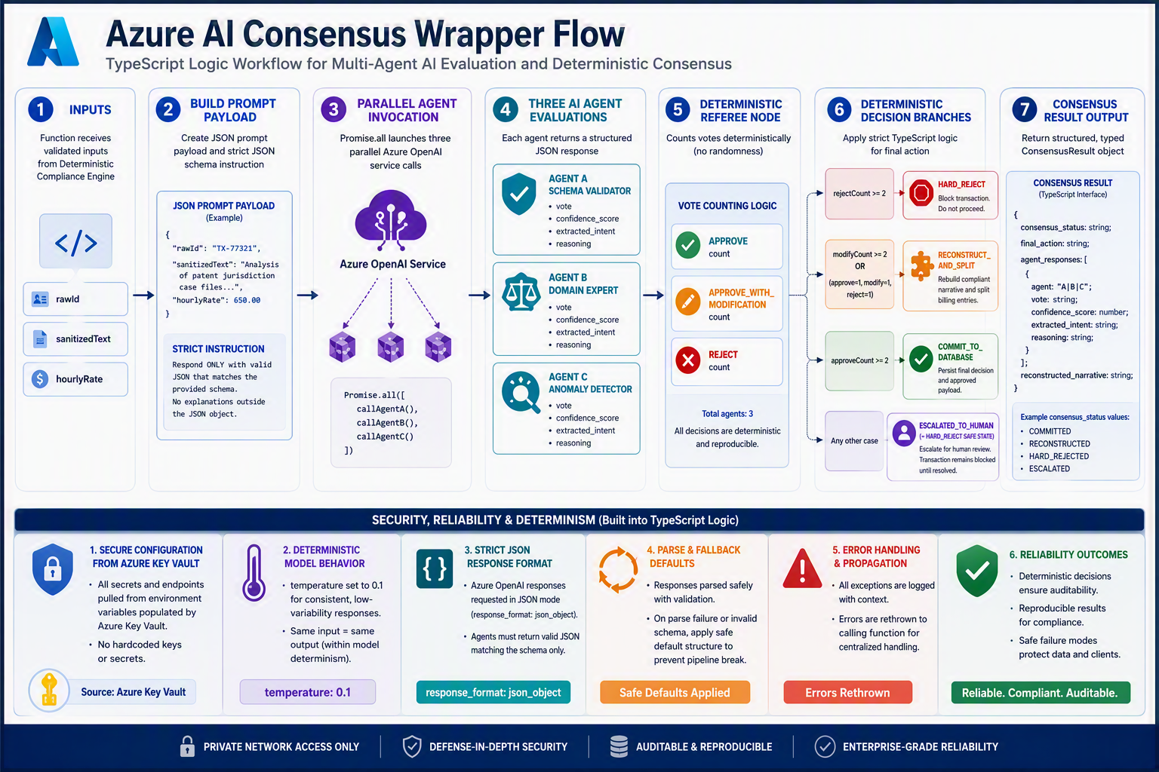

Deterministic Referee Logic
Observed Vote Pattern | Consensus Status | Final Action | Narrative Treatment
Two or more REJECT votes | RESOLVED | HARD_REJECT | Keep the sanitized input as the returned narrative.
Two or more APPROVE_WITH_MODIFICATION votes | RESOLVED | RECONSTRUCT_AND_SPLIT | Join non-empty extracted_intent values with “ and ”.
One APPROVE, one MODIFY, one REJECT | RESOLVED | RECONSTRUCT_AND_SPLIT | Join non-empty extracted_intent values.
Two or more APPROVE votes | RESOLVED | COMMIT_TO_DATABASE | Keep the sanitized input.
Any other reachable pattern | ESCALATED_TO_HUMAN | HARD_REJECT | Use the coded blocked safe state pending review.

WHY THIS MATTERS
The agent analysis is probabilistic, but the referee thresholds are inspectable TypeScript rules. This makes the selected system action easier to test, explain, and audit than an unconstrained model deciding the final route by itself.

Typed Output Contract
Field | Meaning
consensus_status | Whether the wrapper resolved the vote pattern or escalated it to human review.
final_action | The coded downstream instruction: commit, reconstruct and split, or hard reject.
agent_responses | All three AgentVote objects, including names, votes, confidence scores, intents, and reasoning.
reconstructed_narrative | The original sanitized narrative or the joined extracted intents, depending on the branch.

Reliability and Control Features
- Parallel execution: Promise.all starts all three agent calls in one asynchronous block instead of waiting for each sequentially.
- Low-temperature request: the code sets temperature to 0.1 to reduce variability, but this does not make model output mathematically deterministic.
- JSON mode: responseFormat requests a valid JSON object. Microsoft notes that JSON mode validates JSON syntax but does not guarantee adherence to a specific schema.
- Defensive defaults: missing parsed fields fall back to REJECT, 0.0, empty text, or a parsing-failure reason.
- Explicit failure handling: exceptions are logged and rethrown to the caller rather than converted into a false successful result.
- Secret externalization: endpoint, API key, and deployment ID are read from environment variables rather than embedded as active credentials in the class.
IMPORTANT TECHNICAL DISTINCTION
Format: { type: "json_object" } is JSON mode, not a schema validator. For stronger field and enum enforcement, use Structured Outputs where the selected model and API support it. This model presumes local data validation of parsed data prior to counting votes. Human in the loop design.

Implementation Risks and Recommended Hardening
Area | Current Behavior | Recommended Hardening
Endpoint fallback | Falls back to the literal string rendered as https://azure.com if the environment variable is absent. | Require a valid Azure OpenAI endpoint and fail closed when it is missing or malformed.
Authentication | Uses AzureKeyCredential with an environment-provided API key. | Consider Microsoft Entra ID or managed identity for deployed workloads when supported by the hosting design.
Output validation | JSON.parse is used and individual fields receive defaults. | Validate the full object, allowed enums, confidence range, required strings, and agent identity before vote counting.
Confidence score | Returned and stored, but not used by the referee. | Define whether confidence affects escalation; otherwise label it as informational.
Narrative reconstruction | Joins all non-empty extracted intents, including a rejecting agent’s intent. | Decide which votes may contribute; deduplicate, normalize, preserve provenance, and validate the result before use.
Human escalation branch | With exactly three votes restricted to three valid enum values, the listed count branches appear to cover every valid combination. | Use malformed, missing, duplicate, or policy-threshold conditions as explicit escalation triggers if human review must remain reachable.
Error handling | Logs and rethrows the raw error. | Attach correlation IDs, avoid sensitive payload logging, classify retryable failures, and persist a safe transaction state.
SDK lifecycle | Uses the supplied @azure/openai OpenAIClient pattern. | Pin and test the SDK/API version and review migration guidance before production release.

Why the Component Is Important to DRE
The wrapper gives the deterministic compliance engine a controlled way to request interpretive assistance only for flagged narratives. It preserves three agent records, separates model evaluation from final routing, and returns one typed object that downstream storage or human-review components can process.
- Separation of duties: schema, domain, and anomaly perspectives are requested independently.
- Latency control: the three calls execute concurrently.
- Traceability: each vote includes a name, confidence score, extracted intent, and reasoning.
- Deterministic routing: final actions are chosen by explicit counts and thresholds.
- Safe failure behavior: missing fields bias toward rejection and execution errors propagate.
- Integration clarity: the ConsensusResult interface defines the handoff to database, reconstruction, rejection, or review workflows.
BOTTOM LINE
consensuswrapper_ts is the interpretive exception boundary for DRE. It does not replace the deterministic engine. It takes a flagged, sanitized item, gathers three structured perspectives, applies explicit referee rules, and returns a traceable action package. Its production strength will depend on schema validation, identity, private connectivity, telemetry, retry design, and a deliberately reachable human-review path.

Source Notes
The component explanation and branch table are based on the TypeScript below. Microsoft documentation used to clarify JSON output behavior:
- Microsoft Learn, JSON mode for Azure OpenAI: https://learn.microsoft.com/en-us/azure/foundry/openai/how-to/json-mode
- Microsoft Learn, Structured outputs with Azure OpenAI: https://learn.microsoft.com/en-us/azure/foundry/openai/how-to/structured-outputs
Microsoft states that JSON mode guarantees valid JSON but does not guarantee conformance to a specific schema; Structured Outputs adds schema constraints. Recommendations in this document are design suggestions and are not claims that the current component already implements them.

npm install @azure/openai

import { OpenAIClient, AzureKeyCredential } from "@azure/openai";

// Define strict types for the Agent Consensus outputs
export interface AgentVote {
agent_name: string;
vote: "APPROVE" | "APPROVE_WITH_MODIFICATION" | "REJECT";
confidence_score: number;
extracted_intent: string;
reasoning: string;
}

export interface ConsensusResult {
consensus_status: "RESOLVED" | "ESCALATED_TO_HUMAN";
final_action: "COMMIT_TO_DATABASE" | "RECONSTRUCT_AND_SPLIT" | "HARD_REJECT";
agent_responses: AgentVote[];
reconstructed_narrative: string;
}

export class AzureAiConsensusWrapper {
private client: OpenAIClient;
private deploymentId: string; // e.g., "gpt-4o-deployment"

constructor() {
// These environment variables will be securely injected from your Azure Key Vault
const endpoint = process.env.AZURE_OPENAI_ENDPOINT || "https://azure.com";
const apiKey = process.env.AZURE_OPENAI_API_KEY || "";
this.deploymentId = process.env.AZURE_OPENAI_DEPLOYMENT_ID || "gpt-4o";

if (!apiKey) {
throw new Error("Missing AZURE_OPENAI_API_KEY environment variable.");
}

this.client = new OpenAIClient(endpoint, new AzureKeyCredential(apiKey));
}

// System instructions for the 3 distinct consensus agents
private agentPersonas = {
Schema_Validator: "You are Agent A: Schema Validator. Your job is to verify if the narrative aligns with structured billable formats. Respond ONLY in strict JSON.",
as administrative legalx. Respond ONLY in strict JSON.",
Anomaly_Detector: "You are Agent C: Anomaly Detector. Your job is to spot 'block-billing' (bundling unrelated tasks to hide bloat). Respond ONLY in strict JSON."
};

/**
* Fires parallel requests to Azure OpenAI to get consensus on a flagged narrative string
*/
public async executeConsensusLoop(
rawId: string,
sanitizedText: string,
hourlyRate: number
): Promise<ConsensusResult> {

// Create the JSON prompt structure that the agents must evaluate
const promptPayload = JSON.stringify({
item_id: rawId,
narrative_to_evaluate: sanitizedText,
rate_context_usd: hourlyRate
});

const standardJsonSchemaInstruction = `
Return ONLY a raw JSON block matching this exact structure:
{
"vote": "APPROVE" | "APPROVE_WITH_MODIFICATION" | "REJECT",
"confidence_score": 0.00 to 1.00,
"extracted_intent": "Brief string summarizing the true compliance action",
"reasoning": "One sentence technical validation"
}`;

try {
// 🚀 EXECUTING PARALLEL CALLS TO AZURE OPENAI INFRASTRUCTURE
// This spreads the network latency across a single asynchronous execution block
const [responseA, responseB, responseC] = await Promise.all([
this.callAgent("Schema_Validator", this.agentPersonas.Schema_Validator, promptPayload, standardJsonSchemaInstruction),
this.callAgent("Domain_Expert", this.agentPersonas.Domain_Expert, promptPayload, standardJsonSchemaInstruction),
this.callAgent("Anomaly_Detector", this.agentPersonas.Anomaly_Detector, promptPayload, standardJsonSchemaInstruction)
]);

const agentVotes: AgentVote[] = [responseA, responseB, responseC];

// ⚖️ REFEREE NODE CRITICAL EVALUATION LOGIC
// Count up the votes deterministically to determine the final system action
const approveCount = agentVotes.filter(v => v.vote === "APPROVE").length;
const modifyCount = agentVotes.filter(v => v.vote === "APPROVE_WITH_MODIFICATION").length;
const rejectCount = agentVotes.filter(v => v.vote === "REJECT").length;

let consensusStatus: "RESOLVED" | "ESCALATED_TO_HUMAN" = "RESOLVED";
let finalAction: "COMMIT_TO_DATABASE" | "RECONSTRUCT_AND_SPLIT" | "HARD_REJECT" = "COMMIT_TO_DATABASE";
let finalNarrative = sanitizedText;

if (rejectCount >= 2) {
finalAction = "HARD_REJECT";
} else if (modifyCount >= 2 || (approveCount === 1 && modifyCount === 1 && rejectCount === 1)) {
finalAction = "RECONSTRUCT_AND_SPLIT";
// Combine the extracted intents from the parallel agents to rebuild a clean text block
finalNarrative = agentVotes.map(v => v.extracted_intent).filter(Boolean).join(" and ");
} else if (approveCount >= 2) {
finalAction = "COMMIT_TO_DATABASE";
} else {
// Tied or chaotic voting patterns are instantly escalated to human review (Safe State Rule)
consensusStatus = "ESCALATED_TO_HUMAN";
finalAction = "HARD_REJECT";
}

return {
consensus_status: consensusStatus,
final_action: finalAction,
agent_responses: agentVotes,
reconstructed_narrative: finalNarrative
};

} catch (error) {
console.error("Critical failure during parallel Azure OpenAI network execution loop:", error);
throw error;
}
}

/**
* Helper function to execute a single OpenAI chat completion stream
*/
private async callAgent(
name: string,
systemPersona: string,
payload: string,
schemaInfo: string
): Promise<AgentVote> {
const messages = [
{ role: "system", content: `${systemPersona}\n${schemaInfo}` },
{ role: "user", content: `Evaluate this transaction context: ${payload}` }
];

const result = await this.client.getChatCompletions(this.deploymentId, messages, {
temperature: 0.1, // Near zero temperature enforces deterministic outputs from the LLM model
responseFormat: { type: "json_object" } // Hard forces Azure OpenAI to output a clean parseable JSON object
});

const rawChoiceText = result.choices[0].message?.content || "{}";
const parsedData = JSON.parse(rawChoiceText);

return {
agent_name: name,
vote: parsedData.vote || "REJECT",
confidence_score: parsedData.confidence_score || 0.0,
extracted_intent: parsedData.extracted_intent || "",
reasoning: parsedData.reasoning || "Failed to parse node output context."
};
}
}

