Enterprise Revenue Firewall Demo
Application Mailer Demonstration Summary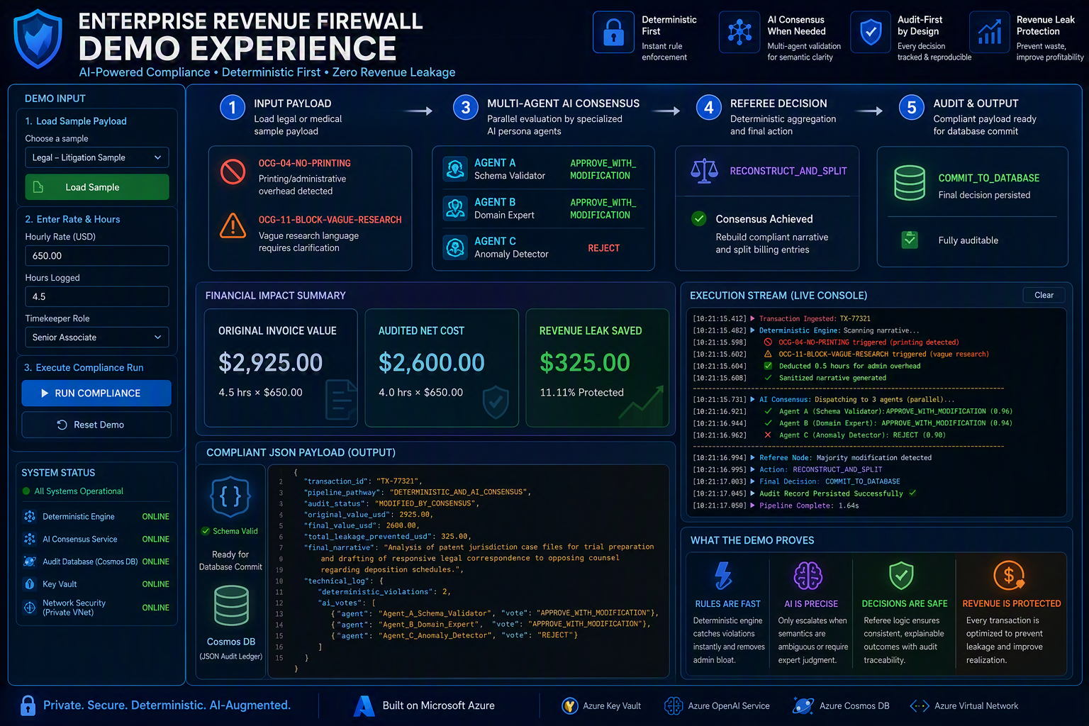
Overview
This demonstration shows a deterministic-first compliance firewall that reviews billing or claims narratives before downstream processing.
Demo Flow
Users load a sample payload, execute deterministic rules, escalate only flagged narratives to multi-agent consensus review, apply referee logic, calculate financial impact, and produce a compliant JSON payload.
What the Demo Proves
Deterministic controls catch prohibited activities immediately, AI review is reserved for semantic ambiguity, consensus results remain auditable, and every transaction produces a structured output receipt.
Key Business Value
Revenue protection, compliance enforcement, audit traceability, controlled AI usage, and repeatable operational workflows.
Core Components
Payload ingestion, deterministic compliance engine, AI consensus service, referee node, financial calculations, audit database record, and compliant JSON output.
Illustrative Outcome
The legal sample demonstrates administrative overhead removal, narrative reconstruction, consensus voting, and measurable financial adjustment before database commit.

Demo Walkthrough
- Load sample transaction | - Aggregate votes through referee logic
- Enter rate and hours | - Calculate final audited value
- Execute compliance run | - Generate compliant JSON payload
- Apply deterministic rules | - Persist approved transaction
- Escalate semantic issues to consensus agents

