DRE RUNTESTS_TS
Infrastructure Relevance and Validation Role
How the supplied Bicep definition supports repeatable testing of the Legal Firewall Azure foundation

DOCUMENT PURPOSE
This document explains why the supplied infrastructure definition is relevant to DRE testing. It treats the file as the deployment fixture used by the runtests_ts workflow: the repeatable environment definition against which provisioning, configuration, security, and integration checks can be run.

Infrastructure fixture • test relevance • expected assertions • known gaps

Executive Relevance
The supplied content is Bicep infrastructure code rather than TypeScript test logic. Its relevance to a file or workflow named runtests_ts is that it defines the Azure environment the test runner can deploy, inspect, exercise, and tear down. In other words, runtests_ts can validate application and control behavior only when the underlying resources are created consistently enough to produce repeatable evidence.
WHY IT MATTERS
A test suite is stronger when it validates the real infrastructure contract, not only isolated application functions. This definition gives DRE a concrete baseline for network addressing, resource naming, secrets storage, audit storage, and restricted Azure OpenAI access.

The Infrastructure Contract Created by the File
Resource | Declared Contract | Relevance to Tests
Parameters | Use the resource-group location and the legalfirewall prefix. | Tests can predict region placement and resource-name patterns.
Virtual Network | Create 10.0.0.0/16 with AppSubnet at 10.0.1.0/24. | Tests can confirm that the intended network foundation exists before private integrations are added.
Key Vault | Create a Standard vault with an empty accessPolicies array and deployment integration flags enabled. | Tests can verify vault provisioning and later confirm that the chosen authorization model is added.
Cosmos DB | Create a GlobalDocumentDB account with one primary location. | Tests can verify account creation before database, container, partitioning, and retention tests are introduced.
Azure OpenAI | Create an S0 OpenAI account, custom subdomain, and disabled public network access. | Tests can assert that public network access is disabled and then verify private connectivity after endpoints and DNS are added.

Runtests Infrastructure Validation Flow
Deploy the fixture, validate declared controls, then run service and application checks
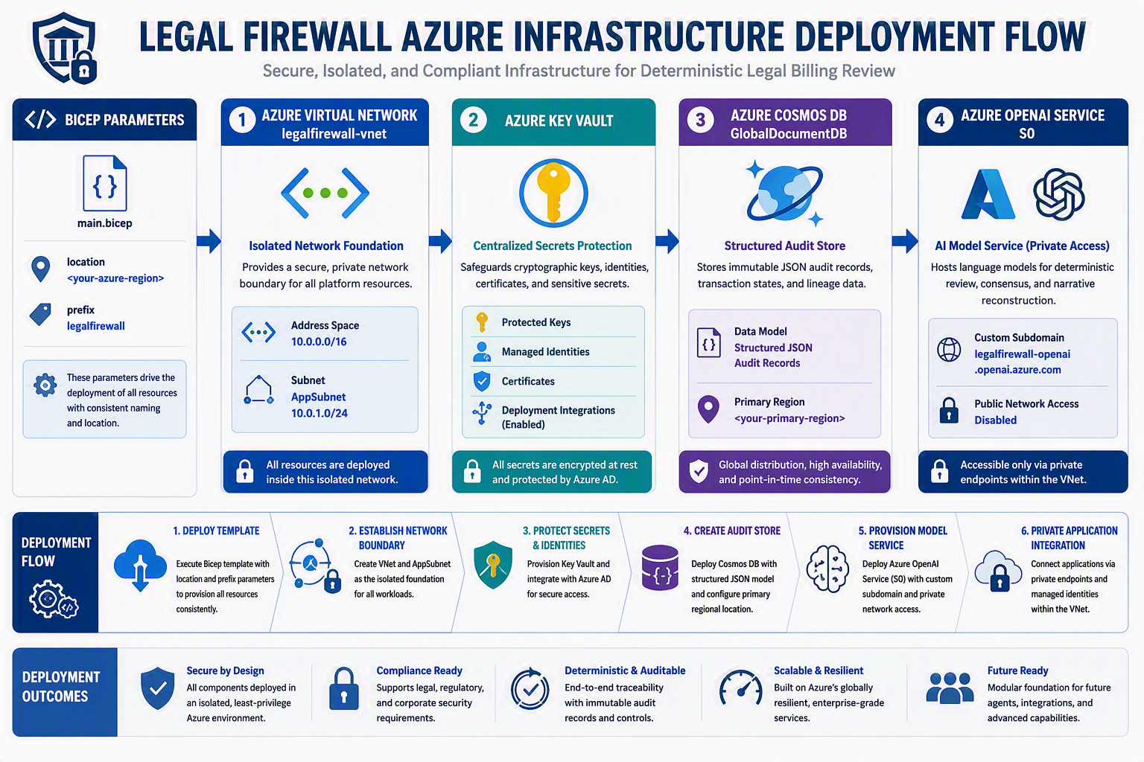
The illustration represents the intended target architecture. The current definition does not yet declare private endpoints, private DNS, identities, databases, containers, model deployments, or monitoring.

What Runtests_TS Should Prove
The most useful role for runtests_ts is to convert the intended infrastructure design into pass-or-fail evidence. The following checks are recommended test objectives, not claims that the supplied file already implements them.
Test Layer | Recommended Assertion | Evidence Produced
Template validation | The Bicep compiles and required parameters resolve. | Build result and deployment-plan output.
Deployment | All four declared resource accounts provision successfully in the selected resource group. | Deployment status and resource identifiers.
Naming | Names use the legalfirewall prefix and unique-string suffix where declared. | Resource inventory comparison.
Network | The VNet and AppSubnet use the declared address prefixes without overlap. | Network resource properties.
Key Vault | The vault exists and the final implementation uses an explicitly tested authorization and network configuration. | Access-control and connectivity test results.
Cosmos DB | The account exists; later tests validate database, container, authorization, backup, and private access configuration. | Data-plane and control-plane test results.
Azure OpenAI | publicNetworkAccess equals Disabled; later tests confirm approved private resolution and access. | Configuration assertion and private connectivity result.
Negative security | Public or unauthorized paths fail once the complete private-access design is implemented. | Expected-denial results and security logs.
Cleanup and repeatability | A test environment can be redeployed consistently and removed without orphaned resources. | Repeated deployment comparison and cleanup report.

Why This Is Important to DRE
- Reliability: repeatable infrastructure reduces differences between development, test, pilot, and production-like environments.
- Security evidence: assertions make restricted access and authorization testable instead of relying on architectural intent alone.
- Auditability: deployment output and test results create traceable evidence showing which configuration was evaluated.
- Change control: when the Bicep changes, runtests_ts can detect unexpected differences before a release advances.
- Investor and customer credibility: tested controls support more disciplined claims than diagrams or comments alone.
- Faster troubleshooting: failed tests identify whether a defect belongs to infrastructure, connectivity, identity, data storage, or application behavior.
KEY DISTINCTION
The Bicep file defines the environment. The runtests_ts logic should verify the environment. Keeping those roles separate makes failures easier to diagnose and helps preserve a clean evidence trail.

Current Limitations and Test Gaps
The comments describe an isolated, high-security target, but the supplied declarations do not yet implement the complete target. The test plan should expose these gaps rather than assuming them away.
Gap | Why a Test Should Catch It | Expected Future Validation
No private endpoints or private DNS | Disabling public access does not itself create a reachable private path. | Confirm private name resolution, private IP routing, and denied public access.
No role assignments or managed identities | The vault has an empty accessPolicies array and no alternate authorization is declared here. | Confirm least-privilege application and deployment identities.
No Cosmos database or container | The account alone does not define the audit data model. | Confirm database/container creation, partition key, retention, and authorized data access.
No Azure OpenAI model deployment | The account does not identify a deployed model for application calls. | Confirm approved model deployment, quotas, content controls, and private invocation.
No diagnostics or monitoring | Failures and access events are not routed by this file. | Confirm diagnostic settings, log destinations, alerting, and correlation identifiers.
No environment lifecycle controls | The file does not show tags, locks, policy assignments, or teardown behavior. | Confirm ownership tags, policy compliance, safe cleanup, and absence of orphaned resources.

Recommended Runtests_TS Execution Pattern
Stage | Purpose | Result
1. Static checks | Compile and lint Bicep, validate parameter constraints, and inspect the planned resource graph. | Reject malformed or unintended infrastructure before deployment.
2. Ephemeral deploy | Deploy to an authorized test resource group using a unique test run identifier. | Create an isolated, attributable test environment.
3. Control assertions | Read resource properties and compare them with the expected contract. | Produce deterministic pass/fail evidence.
4. Connectivity tests | Exercise approved and denied network paths after private endpoints and DNS are implemented. | Prove intended reachability and isolation.
5. Data and model tests | Write/read a controlled audit record and invoke an approved model deployment after service configuration exists. | Verify end-to-end service integration.
6. Evidence capture | Store deployment outputs, test results, configuration snapshots, and correlation IDs. | Create a reviewable run record.
7. Cleanup | Remove the test resources according to policy and check for leftovers. | Return the environment to a known state.

BOTTOM LINE
This file is relevant because it supplies the repeatable Azure foundation that runtests_ts can validate. Its real value is not merely provisioning resources. Its value is enabling DRE to demonstrate, with repeatable evidence, that named controls are present, unwanted paths are denied, and future infrastructure changes do not silently weaken the platform.

Microsoft documentation used to validate the private-access and infrastructure-as-code context:
- Microsoft Learn, Configure Azure Private Link for Azure Cosmos DB: https://learn.microsoft.com/en-us/azure/cosmos-db/how-to-configure-private-endpoints
- Microsoft Learn, Integrate Key Vault with Azure Private Link: https://learn.microsoft.com/en-us/azure/key-vault/general/private-link-service
- Microsoft Learn, Manage Azure Cosmos DB resources with Bicep: https://learn.microsoft.com/en-us/azure/cosmos-db/manage-with-bicep
Recommended assertions and execution stages are design suggestions for the future runtests_ts implementation. They are not evidence that the tests currently exist or pass.

import { DeterministicComplianceEngine, RawBillingPayload } from './complianceEngine';
import * as fs from 'fs';

// Initialize the deterministic engine instance
const engine = new DeterministicComplianceEngine();

// Load the raw sample dataset mock file
const sampleRawData: RawBillingPayload[] = [
{
line_item_id: "TX-1001",
timekeeper_role: "Partner",
hourly_rate_usd: 850.00,
hours_logged: 3.2,
raw_narrative_text: "Attended internal alignment session, printed out the defense binders for trial, and began broad legal research regarding jurisdiction updates."
},
{
line_item_id: "TX-1002",
timekeeper_role": "Senior Associate",
hourly_rate_usd": 600.00,
hours_logged: 5.0,
raw_narrative_text: "Drafted summary judgment response. Conducted photocopy tasks for client files. Reviewed opposing counsel's recent discovery requests."
},
{
line_item_id: "TX-1003",
timekeeper_role": "Junior Associate",
hourly_rate_usd": 450.00,
hours_logged: 2.5,
raw_narrative_text: "Conducted file prep for the upcoming deposition and performed scanning of evidentiary documents into the database record."
}
];

console.log("=================================================================");
console.log("⚡ STARTING LIVE DETERMINISTIC ENGINE COMPLIANCE RUN");
console.log("=================================================================\n");

let totalSavingsAccumulated = 0;
let itemsProcessedCount = 0;

sampleRawData.forEach((item) => {
itemsProcessedCount++;
console.log(`[Processing Item ${itemsProcessedCount}] ID: ${item.line_item_id} (${item.timekeeper_role})`);
console.log(`- Original Text: "${item.raw_narrative_text}"`);

// Run payload execution loop through the engine
const assessment = engine.evaluatePayload(item);

totalSavingsAccumulated += assessment.revenue_leakage_prevented_usd;

console.log(`- Engine Evaluation Status: ${assessment.needs_ai_consensus ? '⚠️ FLAG FOR AI CONSENSUS' : '✅ CLEAN PASS'}`);
console.log(`- Violations Tripped: ${assessment.violations_detected.length}`);

assessment.violations_detected.forEach(v => {
console.log(` * ${v.rule_id} -> Action Taken: [${v.action}]`);
});

console.log(`- Cleaned Text Base: "${assessment.sanitized_narrative_base}"`);
console.log(`- Tracked Financial Leakage Stopped: $${assessment.revenue_leakage_prevented_usd.toFixed(2)}`);
console.log("-----------------------------------------------------------------\n");
});

console.log("=================================================================");
console.log("📊 DEMO COMPLETED");
console.log(`- Total Transactions Audited: ${itemsProcessedCount}`);
console.log(`- Instant Revenue Saved for Firm Portfolio: $${totalSavingsAccumulated.toFixed(2)}`);
console.log("=================================================================");

