LEGAL FIREWALL
Azure Infrastructure Deployment Process
How the Bicep template establishes the network, secrets, audit, and AI service foundation for DRE

EXECUTIVE PURPOSE
This template begins the infrastructure foundation for a controlled legal billing review platform. It standardizes resource naming and region placement, creates a network boundary, provisions central secrets management, creates a JSON-oriented audit account, and deploys an Azure OpenAI resource with public network access disabled.

Process guide • architecture flow • control importance • implementation gaps

What the Template Does
The Bicep file declares two reusable parameters and four Azure resources. The location parameter inherits the resource group location, while the prefix parameter applies a consistent legalfirewall naming convention. Azure Resource Manager then deploys the declared resources as one repeatable infrastructure definition.
Step | Declared Resource | Configuration in This Template
1 | Azure Virtual Network | 10.0.0.0/16 address space with AppSubnet at 10.0.1.0/24.
2 | Azure Key Vault | Standard vault, empty access policy list, and deployment, disk-encryption, and template-deployment integration flags enabled.
3 | Azure Cosmos DB account | GlobalDocumentDB account with Standard offer type and one primary regional location.
4 | Azure OpenAI account | OpenAI cognitive services account on S0 with a custom subdomain and public network access disabled.

Plain-English Deployment Sequence
- Resolve the deployment region and legalfirewall resource-name prefix.
- Create the virtual network and AppSubnet as the intended private network foundation.
- Create Key Vault to centralize keys, certificates, credentials, and other protected configuration.
- Create the Cosmos DB account intended to hold structured JSON audit information and transaction state.
- Create the Azure OpenAI resource and disable its public network access.
- Connect application workloads, identities, permissions, private endpoints, monitoring, and data-retention controls in subsequent infrastructure modules.
CRITICAL READING
The current template provisions four resource accounts, but it does not yet connect all of them privately. The VNet exists, and Azure OpenAI public access is disabled, but no private endpoint, private DNS zone, subnet delegation, network ACL, role assignment, Cosmos DB database/container, model deployment, or monitoring resource is declared in the supplied code.

Legal Firewall Azure Infrastructure Deployment Flow
Conceptual target flow based on the supplied Bicep resources
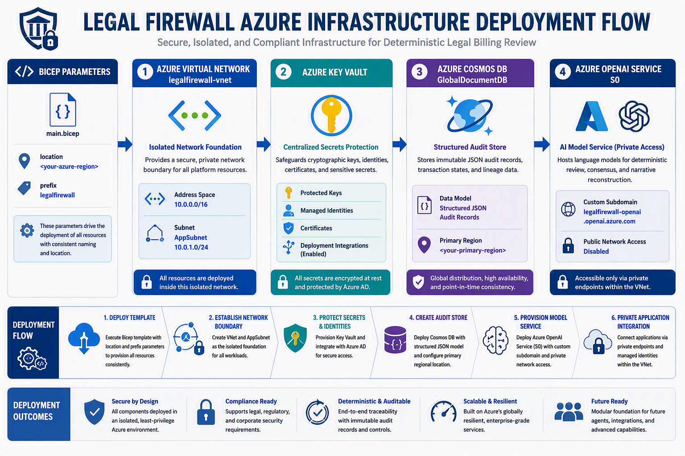
Important: the illustration shows the intended private integration target. The supplied template still requires private endpoints, DNS, identities, access controls, and service-level configuration to realize the full design.

Why Each Control Matters
Control | Why It Matters | Why It Is Important for DRE
Consistent parameters and naming | Repeatable naming and region selection reduce manual deployment variation. | A controlled platform benefits from predictable environments, easier inventory, and clearer operational ownership.
Virtual network boundary | A VNet provides the address space into which private endpoints and application workloads can be attached. | Sensitive billing transactions should follow explicitly designed network paths rather than default public connectivity.
Centralized key management | Key Vault provides a dedicated resource for keys, secrets, and certificates. | Separating protected material from application code supports stronger credential handling and rotation practices.
Structured audit account | Cosmos DB is provisioned as the account intended for JSON-oriented transaction and audit records. | DRE needs a durable record of input, rule path, processing state, recommendation, and authorized disposition.
OpenAI public access disabled | The OpenAI resource rejects public network access at the account setting level. | Model evaluation should be reachable only through an approved private connectivity design once the private endpoint and DNS configuration are added.
Infrastructure as code | Bicep expresses the resources declaratively and supports repeatable Azure deployment. | Versioned infrastructure definitions make architectural changes reviewable and reduce undocumented configuration drift.

Why the Combined Architecture Is Important
The value is not any single Azure resource. The value comes from combining network isolation, controlled identity, protected secrets, structured evidence storage, and restricted model access into one governed processing boundary. For DRE, that boundary helps preserve the distinction between the original billing transaction, deterministic findings, AI-assisted evaluation, and the final authorized action.
INVESTOR AND CUSTOMER SIGNIFICANCE
This infrastructure direction supports a credible enterprise story: deterministic processing first, controlled AI access, explicit evidence storage, and a deployment model designed for customer governance. Stronger claims should wait until the missing private networking, authorization, monitoring, retention, and model-deployment controls are implemented and tested.

Current-State Gap Review
The Bicep is a useful foundation, not a complete secure production deployment. The following items should be treated as implementation work rather than assumed capabilities.
Area | Present in Supplied Code | Still Needed for the Intended Design
Network | VNet and AppSubnet are created. | Private endpoints, private DNS zones and links, subnet policies, routing, network security design, and workload integration.
Key Vault | Vault is created with an empty accessPolicies array and deployment-related flags. | RBAC or access policies, public-network restrictions or private endpoint configuration, purge protection/retention decisions, and audit diagnostics.
Cosmos DB | Database account is created in one region. | Database and containers, partitioning, consistency choice, backup/retention decisions, private access, authorization, and diagnostic settings.
Azure OpenAI | Account is created and publicNetworkAccess is disabled. | Private endpoint and DNS, model deployment, managed identity/RBAC, content filtering decisions, quotas, logging, and application connectivity.
Operations | Resources have consistent names and location. | Tags, budgets, alerts, Log Analytics/Application Insights, policy assignments, locks, disaster-recovery choices, and deployment outputs.
Governance | Infrastructure is declarative. | Environment separation, parameter validation, CI/CD approvals, security testing, evidence retention, and documented operating responsibility.

Recommended Build-Out Order
Phase | Implementation Focus | Exit Condition
1. Foundation | Parameters, naming, tags, VNet, subnet plan, resource locks, and policy baseline. | Resources deploy predictably into the intended environment with ownership and policy metadata.
2. Private Access | Private endpoints and DNS for Key Vault, Cosmos DB, and Azure OpenAI; restrict public access where required. | Approved workloads resolve and reach services privately; unintended network paths are blocked.
3. Identity | Managed identities and least-privilege RBAC for applications, deployment automation, and reviewers. | No application secret is embedded in code; access is attributable and testable.
4. Data and Models | Cosmos database/containers, partition strategy, OpenAI model deployments, content controls, and quotas. | The processing application can store governed records and call an approved model deployment.
5. Observability | Diagnostic settings, Log Analytics, alerts, audit events, and operational dashboards. | Access, failures, latency, policy events, and deployment changes are observable.
6. Assurance | Threat modeling, deployment tests, access reviews, recovery tests, retention validation, and documentation. | The architecture has evidence-backed security and operating claims suitable for pilots.

BOTTOM LINE
The supplied Bicep establishes the beginning of a secure Azure landing pattern for Legal Firewall. Its strongest current controls are repeatable infrastructure definition and disabled public access on the Azure OpenAI account. The full private, least-privilege, auditable architecture depends on the next layer of endpoints, DNS, identities, service configuration, monitoring, and governance.

Source Notes
The architecture description is based on the Bicep code supplied for this document. Microsoft documentation used to validate service and template terminology:
- Microsoft Learn: Microsoft.KeyVault/vaults Bicep resource reference — https://learn.microsoft.com/en-us/azure/templates/microsoft.keyvault/vaults
- Microsoft Learn: Manage Azure Cosmos DB for NoSQL resources with Bicep — https://learn.microsoft.com/en-us/azure/cosmos-db/manage-with-bicep
This document explains an intended architecture and implementation sequence. It is not a certification, security guarantee, legal opinion, or confirmation that the environment has been deployed or tested.

