DRE
DR. E | DETERMINISTIC REVIEW ENGINE
A deterministic-first revenue protection gateway for legal pre-billing and Outside Counsel Guidelines enforcement

THE INVESTMENT THESIS
DRE is being developed to stop preventable billing defects before they become client deductions. It combines structured schema validation, policy enforcement, financial and client context, authorized performance records, repeated multi-agent consensus for quarantined exceptions, and final human authority.
Investor-facing long-form sales sheet
Proprietor: Jamie Lynn Schallert | Independent software venture

The Opportunity
Legal billing is governed by two realities at once: the billing system must receive correctly structured transaction data, and each client may impose detailed Outside Counsel Guidelines that determine what will be accepted, reduced, questioned, or rejected. The costly failure is often discovered late, after time has been entered, reviewed, invoiced, and challenged.
DRE is being built as a pre-billing control layer. It is intended to evaluate a billing transaction before downstream submission, resolve what can be resolved through deterministic controls, quarantine what requires contextual review, and preserve a complete audit trail for the human decision-maker.
NOT AN AI CHATBOT
DRE does not begin with an open-ended model prompt. The transaction first passes through deterministic schema and policy controls. Multi-agent analysis is reserved for quarantined items that cannot be safely resolved by defined rules alone.

The Product in One Sentence
DRE is a deterministic-first review engine that intercepts structured legal billing transactions, validates their form and policy fit against financial, client, and authorized performance context, and routes exceptions through repeated three-agent consensus before a referee node prepares a recommendation for human review.

What DRE Is Designed to Protect
- Revenue that would otherwise be delayed, reduced, or written off after a client billing challenge.
- Attorney and billing-team time consumed by preventable corrections and resubmissions.
- Client trust by applying the client’s own governing rules before invoice delivery.
- Auditability by preserving the original transaction, rule path, consensus record, recommendation, and human disposition.
- Operational control by keeping deterministic rules and human authority ahead of generative judgment.

Why the Wedge Is Legal Pre-Billing
The initial market is automated pre-billing and OCG enforcement for law firms. The entry point is narrow enough to measure and important enough to matter: evaluate billing narratives and transaction metadata before they become invoice problems. The same engine pattern may later support other high-compliance transaction environments, but the launch language should remain legal-first.

How DRE Works
DRE receives a structured billing transaction, validates required fields and integrity, applies the governing policy context, resolves hard-rule issues deterministically, and isolates semantic exceptions for controlled review.
# | Control Point | Purpose
1 | INGEST | Receive the billing transaction, metadata, narrative, matter identifiers, timekeeper context, and applicable references.
2 | SCHEMA VALIDATION | Confirm required fields, types, formats, relationships, identifiers, and transaction integrity before policy analysis.
3 | POLICY EVALUATION | Apply the governing OCG and configured rules with relevant financial, client, and authorized performance context.
4 | DETERMINISTIC ROUTING | Send clearly compliant items forward. Quarantine violations, ambiguity, missing support, conflicts, or unresolved semantic issues.
5 | REPEATED CONSENSUS | Run quarantined items through three independent agents across three separate rounds, preserving each vote and rationale.
6 | REFEREE SYNTHESIS | Consolidate round-level outcomes into one traceable recommendation without converting it into an autonomous final decision.
7 | HUMAN REVIEW | Present the evidence, proposed treatment, and financial implications to an authorized reviewer for final disposition.
8 | CONTROLLED OUTPUT | After approval, release, modify, reject, split, or return the billing entry and preserve the complete audit record.

The Deterministic Boundary
The deterministic layer is the primary control surface. It handles what software can evaluate consistently and explainably: payload validity, required context, hard prohibitions, numerical or authorization conditions, and safe routing. The rules must be policy-configurable because client, matter, engagement, timekeeper, and approved-arrangement context may differ.

Deterministic Billing Compliance Engine
Rule-driven validation, adjustment, escalation, and traceable output
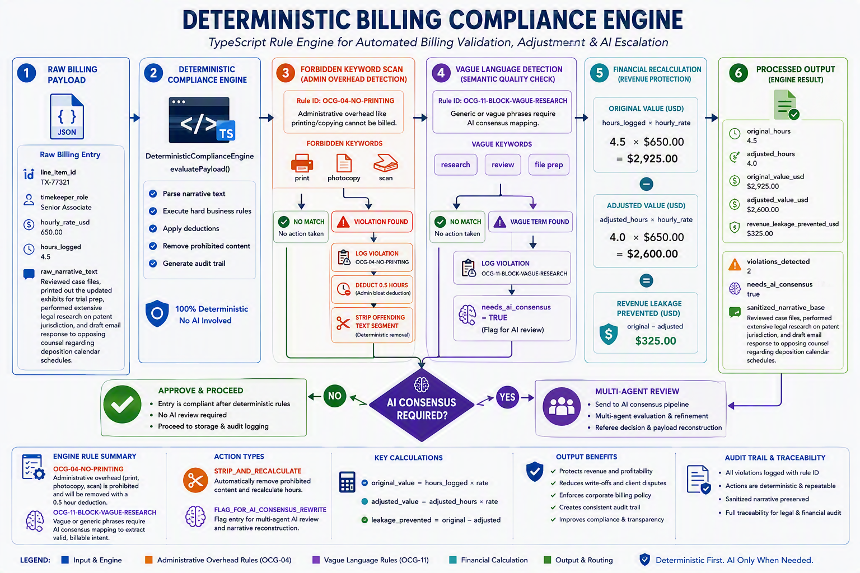
Illustrative implementation flow. Example values are presented to demonstrate engine behavior, not operating results.

The Multi-Agent Exception Boundary
Quarantine is not failure. It is a controlled state for transactions that deserve more scrutiny. When deterministic controls identify ambiguity or cannot resolve a semantic issue safely, DRE invokes its multi-agent review sequence.

Three Agents, Three Rounds, One Referee Recommendation
Each quarantined item is evaluated by three differentiated agents. That three-way review is repeated three times. The system records each agent’s conclusion and reasoning, produces a result for each round, and sends the three round-level outcomes to a referee node for consolidation.
Round | Agent A | Agent B | Agent C
ROUND 1 | Independent evaluation  Vote • rationale • evidence | Independent evaluation  Vote • rationale • evidence | Independent evaluation  Vote • rationale • evidence
ROUND 2 | Independent evaluation  Vote • rationale • evidence | Independent evaluation  Vote • rationale • evidence | Independent evaluation  Vote • rationale • evidence
ROUND 3 | Independent evaluation  Vote • rationale • evidence | Independent evaluation  Vote • rationale • evidence | Independent evaluation  Vote • rationale • evidence

REFEREE NODE
The node compares the three round-level outcomes, identifies agreement and disagreement, and produces a recommendation such as approve, modify, split, reject, request support, or escalate. The output remains pending until an authorized human reviewer acts.

Why Repetition Matters
- Separates the decision record from a single model response.
- Exposes disagreement instead of hiding it inside a polished answer.
- Creates a richer basis for escalation when evidence is mixed.
- Preserves the difference between deterministic findings, model judgments, referee synthesis, and human authority.

What AI Does and Does Not Do
AI May Assist With | AI Does Not Replace
Interpreting narrative meaning in quarantined entries | Schema validation and hard policy controls
Detecting possible block billing or semantic conflicts | The governing client policy
Comparing a narrative with authorized context | The original transaction record
Proposing a correction, split, or request for support | The referee record or audit trail
Explaining agreement and disagreement | The authorized human reviewer

Illustrative Legal Workflow
A billing entry may be structurally valid while still presenting policy concerns such as a prohibited administrative activity, vague research description, unapproved rate, missing authorization, or a mismatch with matter-specific performance records.
RAW ENTRY
“Reviewed case files, printed updated exhibits, performed legal research, and drafted correspondence regarding deposition scheduling.” Associated metadata may include the firm, client, matter, timekeeper, rate, hours, timestamp, and authorized work context.

Illustrative DRE Treatment
Control | Illustrative Treatment
Schema and integrity | Confirm identifiers, amounts, time values, types, and required references.
Financial context | Compare the entry with authorized rate, value, threshold, allocation, and configured financial controls.
Client and matter policy | Apply the correct OCG and matter-specific rules, including prohibited activities and documentary requirements.
Quarantine | Preserve the original entry and isolate unresolved narrative, allocation, authorization, or policy issues.
Consensus review | Run three agents across three rounds and consolidate the results through the referee node.
Human disposition | Allow an authorized reviewer to approve, revise, split, reject, return, or request further support.
Audit output | Store the input, rules fired, context considered, agent votes, referee recommendation, and human decision.

FINANCIAL CLAIM DISCIPLINE
DRE should distinguish identified exposure from realized savings. Before human approval, the system can calculate the amount associated with a flagged or proposed adjustment. After disposition, reporting can describe approved corrections, avoided submission issues, recovered billing value, or other defined measures.

Deployment Vision
DRE is planned as an Azure-native control layer that can connect to established legal billing environments without requiring the firm to replace its system of record. The intended deployment language emphasizes customer control, private connectivity, service isolation, identity, secrets management, structured messaging, observability, and auditable processing.
Capability | Role in DRE
API and execution boundary | Receive transactions and run deterministic processing in a controlled application layer.
Messaging and quarantine | Buffer work, route exceptions, support retries, and preserve controlled processing states.
Private connectivity | Connect services without exposing sensitive transaction flows unnecessarily to public endpoints.
Identity and authorization | Control service identities, customer access, reviewer authority, and administrative privileges.
Secrets and key management | Protect credentials, certificates, encryption material, and signing keys.
Structured audit storage | Preserve transaction state, ruleset version, consensus record, recommendation, and disposition.
Multi-agent model services | Perform repeated exception analysis within the defined consensus boundary.
Monitoring and security | Track health, failure, latency, access, policy events, and security posture.

Deployment Model Language to Lock In
DRE is intended to be deployable within a customer-controlled Azure environment or another clearly defined customer-resident configuration. Final investor and customer language should identify the precise operating model once established, including who operates the control plane, where transaction data is processed, what telemetry leaves the environment, and which party controls keys, identities, logs, and upgrades.
CLAIM DISCIPLINE
Use “designed for customer-controlled deployment,” “private connectivity,” and “human-governed review” unless the finished implementation and contract support stronger statements. Avoid absolute promises such as “zero data leaves,” “100% compliance,” or “zero hallucinations.”

Business Model and Go-to-Market Thesis
The commercial proposition is revenue protection rather than generic automation. A law firm can evaluate DRE against observable operating events: entries quarantined before submission, policy issues corrected, unsupported charges removed or clarified, rework avoided, review effort, and billing value preserved after authorized disposition.

Initial Buyer and User Set
- Law-firm finance and billing leadership responsible for realization, collections, and billing controls.
- Billing attorneys and practice leaders accountable for client-specific compliance.
- Revenue operations, legal operations, and e-billing teams managing OCG rules and exceptions.
- Security, technology, and risk stakeholders responsible for deployment and data governance.
- Authorized human reviewers who make the final decision on quarantined transactions.

Commercial Entry Strategy
Step | Strategy
1 | Start with one controlled pre-billing workflow and prove the audit record before expansion.
2 | Translate selected client-specific OCG requirements into versioned, testable controls.
3 | Report observed issues, approved corrections, review effort, and resulting financial effect.
4 | Expand by client, matter, or practice based on demonstrated control performance.
5 | Prepare for Microsoft ecosystem routes after the product and enterprise documentation meet applicable requirements.

Potential Revenue Structure
The final pricing model has not been locked in. Investor positioning can frame possible structures without presenting them as commitments: enterprise subscription, deployment and configuration fees, usage-linked processing, managed policy-pack updates, and premium governance or reporting modules.

Defensibility
- A deterministic rules layer that converts client policy into testable, versioned controls.
- A transaction-level evidence model connecting schema, policy, financial, client, and authorized performance context.
- A repeated 3-by-3 consensus record for exceptions rather than a single AI response.
- A referee synthesis layer that highlights disagreement and prepares human review.
- A growing library of governed policy patterns, exception histories, and disposition outcomes.
- Deployment patterns designed for enterprise identity, isolation, audit, and customer control.

What Is Being Built
DRE is a pre-build independent software project with a defined product concept, processing model, legal launch use case, Azure direction, and working technical illustrations. It should be presented as active development, not as a currently deployed production platform or finished commercial product.
# | Priority | Output
1 | Language and rules model | Lock the canonical product description, transaction states, policy vocabulary, and audit terminology.
2 | Deterministic engine | Implement schema validation, policy evaluation, contextual checks, routing, and immutable event records.
3 | Quarantine and consensus | Implement the three-agent, three-round workflow and referee synthesis with traceability.
4 | Human review | Create the reviewer experience, evidence presentation, authorization model, and controlled disposition actions.
5 | Integration boundary | Define adapters for structured intake and controlled output to downstream billing environments.
6 | Enterprise controls | Implement identity, secrets, private connectivity, monitoring, retention, and deployment governance.
7 | Measured pilot | Run authorized sample or pilot transactions and report observed control and financial outcomes.
8 | Commercial packaging | Finalize pricing, support, deployment responsibility, Marketplace materials, and investor data room content.

Known Decisions to Preserve
- Product name: DRE or Dr. E, meaning Deterministic Review Engine.
- Proprietor: Jamie Lynn Schallert.
- Venture identity: independent software venture.
- Initial market: legal pre-billing and Outside Counsel Guidelines enforcement.
- Primary control model: deterministic schema and policy evaluation using relevant financial, client, and authorized performance context.
- Exception model: three agents across three rounds, followed by referee-node consolidation and human review.
- Authority model: the system recommends; an authorized human makes the final disposition.

Investor Case
DRE is built around a clear asymmetry. A billing defect may be inexpensive to detect before submission but costly to remediate after it travels through review, invoicing, client audit, dispute, reduction, and collection. The product’s wedge is to move that control point earlier while giving firms a defensible record of how each questioned transaction was handled.

Why This Can Become a Platform
The legal product is not merely a narrative rewriter. The underlying engine governs structured transactions through an ordered system of validation, policy context, quarantine, repeated consensus, referee synthesis, and human disposition. That architecture can support additional legal transaction controls over time without abandoning the deterministic-first principle.

What Investors Should Evaluate
- Whether DRE can translate real OCG requirements into accurate, maintainable controls.
- Whether the quarantine system catches meaningful exceptions without overwhelming reviewers.
- Whether repeated consensus improves exception analysis enough to justify cost and latency.
- Whether the referee output gives humans a clearer and more defensible decision record.
- Whether integration can occur without forcing a firm to replace its core billing platform.
- Whether pilots demonstrate measurable improvement in first-pass billing quality, review effort, and approved financial outcomes.
- Whether deployment, governance, and support can satisfy enterprise legal buyers.

The Ask
DRE is seeking aligned investors, early design partners, and enterprise advisors who understand legal billing, revenue operations, Azure deployment, and controlled AI systems. The immediate objective is to convert a defined operating model into a production-quality legal pre-billing product, validate it against authorized real-world workflows, and establish a repeatable path to enterprise deployment.
THE BOTTOM LINE
DRE is not trying to replace legal judgment with AI. It is building a revenue protection gateway that applies deterministic controls first, reserves repeated multi-agent analysis for quarantined exceptions, and keeps the final decision with an authorized human.

Website-Ready Closing Copy
DRE brings discipline to the point where legal work becomes a billable transaction. It checks structure, applies the correct client policy, considers the authorized financial and performance context, and separates clear outcomes from exceptions. When judgment is required, DRE does not rely on a single AI answer. It runs three agents across three rounds, consolidates the record through a referee node, and presents the result for human review. The goal is simple: find preventable billing problems earlier, preserve the evidence behind every decision, and protect revenue without surrendering control.

Disclosure
DRE is an independent software project in development. Product capabilities, deployment details, integrations, pricing, performance results, Marketplace availability, and commercial terms remain subject to implementation, testing, customer requirements, and final agreements. This document is product and investor positioning material, not a guarantee of compliance, savings, funding, Microsoft program status, or business results.

